**FPY Project Proposal**

**Character/Asset Turntable presentation**

**Student - C00249184**

With this project I will create a 3D model character that will be on an interactable turn table and give it 3 different animations a user can flick through, while in a suited environment to the character. I will end up creating an animation or a turntable display as an end goal.

**With the resources I have, I will be using:**

Apps: Blender, Maya, Procreate, Photoshop to create my art and model assets

Code Language: I can use Python to help produce animation ceratain pieces/ objects / scenery assets or effects in scripting

Design: the end result will be an animation that plays through all the things the character going to the turn table a 360 spin of the character.

The impact is to provide a demonstration of my skills to 3D model a character and animate them in a or on the turntable.

**Work I will Produce:**

* Research Doc and Documentation of work(work journal).
* Drawings: Mood board, concept art, character art(coloured), 360 view (front, side, back, action pose)
* 3D assets & model
* Animation & interactable space

**Core end result:**

An animation that shows the character on the turntable rotating as it goes through 3 animations to showcase it as its in T-pose goes to idle then 2 other animations.

Or An interactable scene where the user can put the character into the different animation states as they do the animation in place as well as rotate the character with the turntable.

References on what I hope to achieve:

<https://discover.therookies.co/2022/04/28/create-a-character-turntable-for-your-3d-portfolio-that-will-impress-recruiters/>

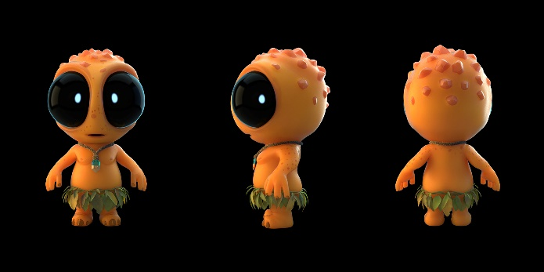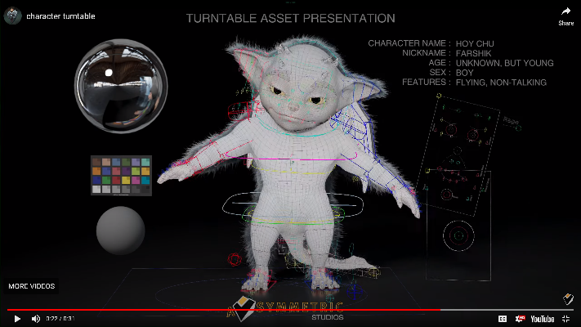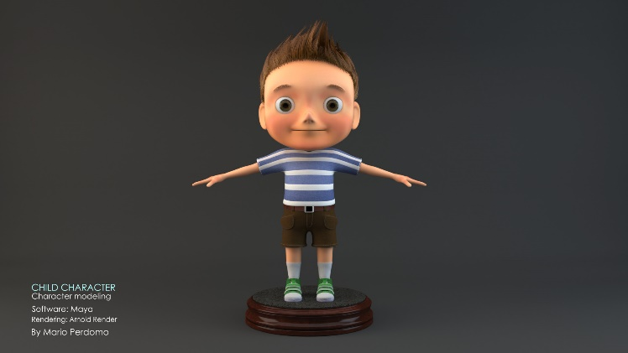<https://www.youtube.com/watch?v=2C9P_E65T2o>

